Welcome to Kodu Game Lab.

What is Kodu?
Kodu lets kids create games on the PC using a simple visual programming language. Kodu can be used to teach creativity, problem solving, storytelling, as well as programming. Anyone can use Kodu to make a game, young children as well as adults with no design or programming skills.

 | Lesson 1 Objectives | Completed
1 | Be able to add a character
2 | Be able to make your character move using the arrows on the keyboard
3 | Be able to add additional characters and make them move
4 | Be able to add objects to your world e.g trees, rocks etc
5 | Be able to change the colour of objects and characters in your world.

Lesson 1

Step 1: Open Kodu
Step 2: Click “New World”
Step 3: Adding land
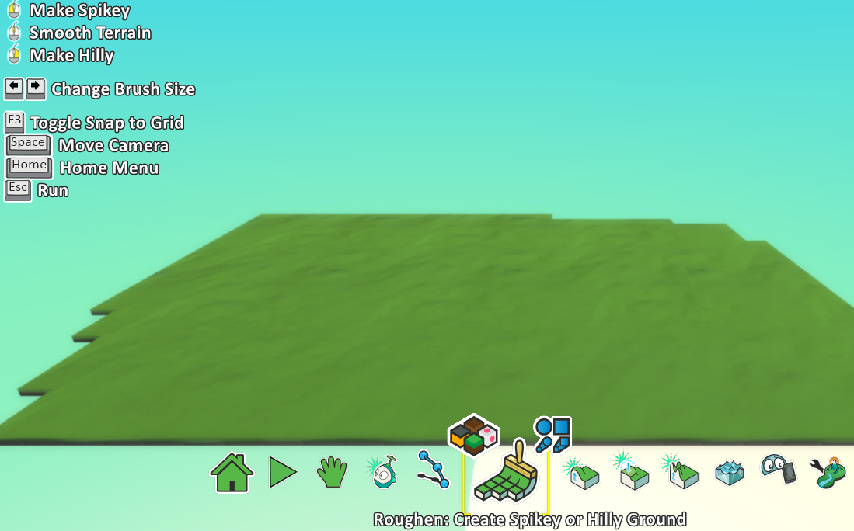
Click on the paint brush icon and then click on the blue screen.
Changing the colour of your land: Click on the four coloured squares above your paint brush and use the arrows on your keyboard to choose one you like.

Step 4: Adding a character
Click on your blue “Kodu” icon and then left click anywhere on your land.

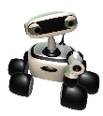
Left click on the character.

Step 5: Making your character move using the keyboard

Right click on your character using your mouse and then left click “Program”.

Left click on the + sign after “When” and click “Keyboard”.
Left click on the + sign after “keyboard” and click “Arrows”.
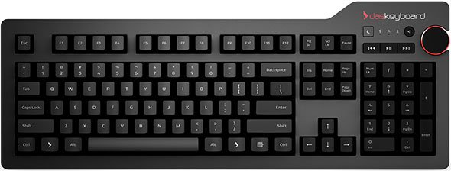
Left click on the + sign after “DO” and click “Move”.
Click “ESC” button on your keyboard.

Step 6: Playing your game
Click the button to play your game.
Use the arrow on your keyboard to control your character.

Click the “ESC” button to go back and add more things to your game.

Lesson 1 Challenges:
- You must add a second character to your game and make it move using without using the arrow keys on your keyboard.
Hint: You can make a character move by itself, using the mouse or using other keys on the keyboard.

- You must add some additional features to your world for example trees and rocks.

- Can you change the colour of characters and objects you added to your world?

